Civil war in Sierra Leone

UNSC Resolution: | 1231
Date of adoption: | 11 March 1999
Operative paragraph: | 3
Demand number: | 1

Megan MacKenzie

Wording of demand

Investigate all allegations of such violations [all violations of human rights and international humanitarian law which have occurred in Sierra Leone during the recent escalation of violence as referred to in paragraphs 21 to 28 of the report of the Secretary-General, including the recruitment of children as soldiers] with a view to bringing the perpetrators of such violations to justice

List of addressees of the demand

Government of Sierra Leone

Short-term compliance

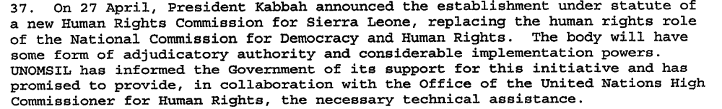

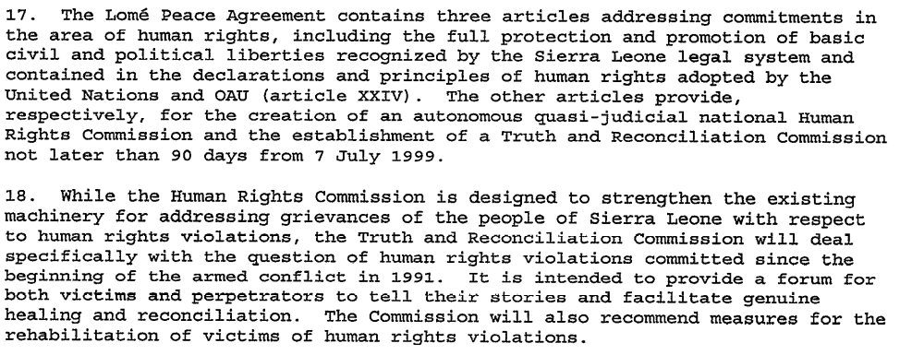

Assessment

Short-term compliance
No or marginal compliance (1) | Medium low compliance (2) | x Medium high compliance (3) | Full or almost full compliance (4)

Considerations underlying the assessment

The Government of Sierra Leone had a limited capacity to investigate allegations of human rights abuses but they made an attempt to create bodies that could address human rights abuses. The demand specifies that the Government have a view of bringing the perpetrators of such violations to justice; yet, the TRC was not a body that could do this.

Medium-term compliance

Assessment

5. The negotiations with the Government of Sierra Leone, represented by the Attorney General and the Minister of Justice, were conducted in two stages. The first stage of the negotiations, held at United Nations Headquarters from 12 to 14 September 2000, focused on the legal framework and constitutive instruments establishing the Special Court: the Agreement between the United Nations and the Government of Sierra Leone and the Statute of the Special Court which is an integral part thereof. (For the texts of the Agreement and the Statute, see the annex to the present report.)

Medium-term compliance
No or marginal compliance (1) | Medium low compliance (2) | x Medium high compliance (3) | Full or almost full compliance (4)

Considerations underlying the assessment

The demand specifically asked for the investigation of “all allegations of such violations.” In many ways this is an almost impossible demand, given the widespread and long term violations of human rights by multiple parties. However, great effort was made to establish the Special Court of Sierra Leone in order to investigate allegations of serious human rights abuses and violations of international law.

Depth of demand

Assessment

Level of depth of demand
Low depth of demand (1) | Medium depth of demand (2) | x High depth of demand (3)

Considerations underlying the assessment

Using the word “all” in this demand made this a high level demand. Complying fully with the demand would have required extensive investigations and a great deal of resources.

Level of confidence about coding decisions

Level of confidence about coding decision
Extremely high | x High | Moderate

Comments to IPI (if any)

Civil war in Sierra Leone

UNSC Resolution: | 1231
Date of adoption: | 11 March 1999
Operative paragraph: | 4
Demand number: | 1

Megan MacKenzie

Wording of demand

respect human rights and international humanitarian law and the neutrality and impartiality of humanitarian workers, and ensure full and unhindered access for humanitarian assistance to affected populations

List of addressees of the demand

Government of Sierra Leone, Armed Forces Revolutionary Council, Civil Defence Forces , Revolutionary United Front

Short-term compliance

Assessment

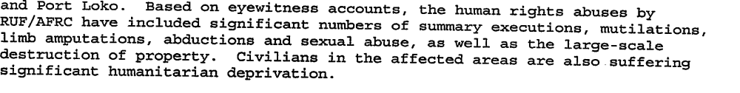
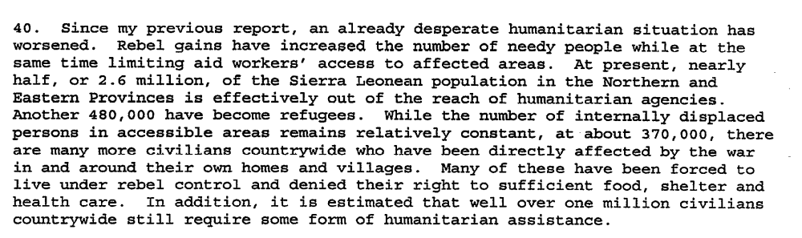
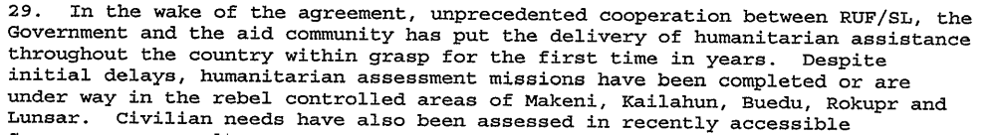

Short-term compliance
x No or marginal compliance (1) | Medium low compliance (2) | Medium high compliance (3) | Full or almost full compliance (4)

Considerations underlying the assessment

The Secretary General’s reports clearly indicate that human rights violations may actually have escalated in some areas during this period. There is clear indication that the parties did not comply with this demand.

Medium-term compliance

Description of the addressee(s)’ conduct

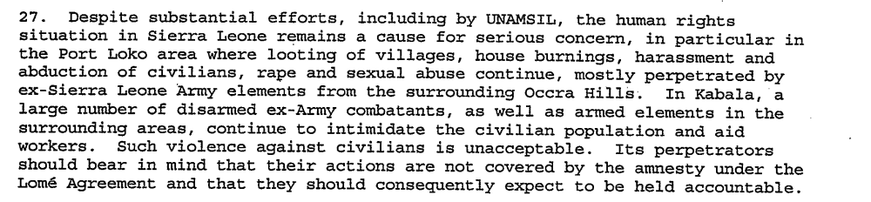
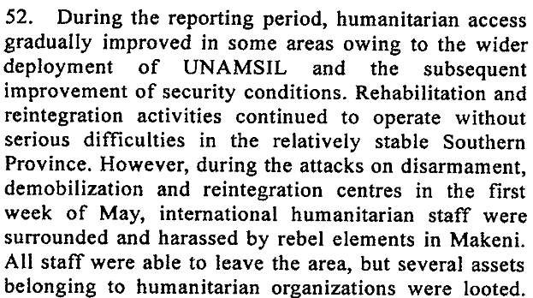

Assessment

Medium-term compliance
No or marginal compliance (1) | x Medium low compliance (2) | Medium high compliance (3) | Full or almost full compliance (4)

Considerations underlying the assessment

There is some indication that the security situation in various regions was improving and that humanitarian access was being facilitated. Despite this, there is also evidence of violence and human rights abuses.

Depth of demand

Assessment

Level of depth of demand
Low depth of demand (1) | Medium depth of demand (2) | x High depth of demand (3)

Considerations underlying the assessment

This was a period characterized by chaos, violence and human rights abuses. By asking the parties to respect human rights and international law as well as facilitating humanitarian access, the UN was demanding that the parties alter their behavior substantially.

Level of confidence about coding decisions

Level of confidence about coding decision
Extremely high | x High | Moderate

Comments to IPI (if any)

Civil war in Sierra Leone

UNSC Resolution: | 1231
Date of adoption: | 11 March 1999
Operative paragraph: | 9
Demand number: | 1

Megan MacKenzie

Wording of demand

participate seriously in these efforts [Government’s dialogue with the rebels]

List of addressees of the demand

Government of Sierra Leone, Armed Forces Revolutionary Council, Civil Defence Forces , Revolutionary United Front

Short-term compliance

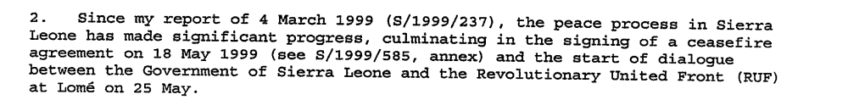
Not a direct quote: By mid year (1999) the government and the RUF has signed two negotiated settlements. Kabbah offered to rescind Sankoh’s death sentence if Sankoh would commit the RUF to a peaceful end to the civil war. Sankoh accepted. Peace negotiations commenced in Togo.

Assessment

Short-term compliance
No or marginal compliance (1) | Medium low compliance (2) | Medium high compliance (3) | x Full or almost full compliance (4)

Considerations underlying the assessment

It is clear from my research that the fighting forces were attempting to participate in dialogue.

Medium-term compliance

Description of the addressee(s)’ conduct

Sierra Leone's rebel Revolutionary United Front say they will fight rather than negotiate unless their leader, Foday Sankoh, is released.
Mr Sankoh was captured by Sierra Leone police in the capital on Wednesday - a week after he fled his Freetown home when rebels shot and killed 19 people protesting at the capture of UN peacekeepers… Mr Massakoi [RUF spokesman] told the French AFP news agency: "We will answer force with force and dialogue with dialogue.
"We want to go back to the negotiating table to make sure that all parties comply with what they signed."
Mr Massakoi said the RUF was committed to the 1999 Lome peace accord, which granted rebels full amnesty for horrific atrocities committed during the brutal eight-year civil war, and gave their leader vice-presidential status in a power-sharing government.
7. The Government of Sierra Leone has established its own indirect contacts with RUF, primarily through traditional leaders and relatives. However, the slow pace at which RUF is implementing aspects of the Abuja Agreement, which were intended to build confidence and pave the way for a political dialogue, has not helped to remove the deep apprehension about the rebels’ intentions.
For months after the Peace Agreement was signed, the RUF complained persistently that the CDF were secretly training fighters in the southern towns of Gbangbatoke and Bonthe in order to launch an attack against them. Whereas the AFRC and RUF had once been allies, the CDF and RUF generally remained sworn enemies, despite instances of peaceful, though wary, co-existence in some mining areas. During the war, the CDF constituted the backbone of resistance to the rebellion. Stories from the warfront ascribe to the CDF a capacity to unleash terror and commit atrocities comparable to those of the RUF, which has contributed to the mistrust and suspicion between the two armed factions.
The examples cited above are part of a larger web of suspicion that seemed to haunt the peace process. Illustrative of this are perceptions of the relationship between Sankoh and chief Samuel Hinga Norman, national coordinator of the CDF and Deputy Defence Minister. They are seen as two old army boys both implicated in coups in the 1960s and 1970s; as knowing each other well from their army days; as rumoured to have worked together for a while in Liberia to plan the 1991 insurgency against the APC government; and as subsequently finding themselves on opposite sides in the rebel war.

Assessment

Medium-term compliance
No or marginal compliance (1) | x Medium low compliance (2) | Medium high compliance (3) | Full or almost full compliance (4)

Considerations underlying the assessment

Committing to dialogue was not a significant commitment for the parties. Parties could behave in provocative or problematic ways but still show signs of commitment to dialogue and still meet the requirements of this demand.

Depth of demand

Assessment

Level of depth of demand
Low depth of demand (1) | x Medium depth of demand (2) | High depth of demand (3)

Considerations underlying the assessment

There is sufficient research indicating dialogue between the Government of Sierra Leone and the RUF; however, it was difficult to find information about the CDF and their behavior. Although the RUF and AFRC were still committing acts of violence during this period, it does appear that they were attempting to participate in dialogue.

Level of confidence about coding decisions

Level of confidence about coding decision
Extremely high | x High | Moderate

Comments to IPI (if any)

United Nations Secretary General. Sixth report of the Secretary-General on UNOMSIL, including recommendations on future deployment 4 June 1999
United Nations Secretary General Seventh report of the Secretary-General on UNOMSIL, including recommendations on an expanded UNOMSIL presence 30 July 1999
United Nations Secretary General. Report of the Secretary-General on the establishment of a Special Court for Sierra Leone. 4 October 2000.
United Nations Secretary General. Sixth report of the Secretary-General on UNOMSIL, including recommendations on future deployment 4 June 1999
United Nations Secretary General Seventh report of the Secretary-General on UNOMSIL, including recommendations on an expanded UNOMSIL presence 30 July 1999
United Nations Secretary General Third report of the Secretary-General covering developments since the second report on UNAMSIL and containing a section describing important objectives of the peace process 7 March 2000
United Nations Secretary General. Fourth report of the Secretary-General on UNAMSIL 19 May 2000
United Nations Secretary General. Sixth report of the Secretary-General on UNOMSIL, including recommendations on future deployment 4 June 1999
Eric G. Berman and Melissa T. Labonte, “Sierra Leone” in William J. Durch ed. Sierra Leone 21st Century Peace Operations. (Washington: United States Institute of Peace) p160.
Rebels Demand Sankoh Release http://news.bbc.co.uk/2/hi/africa/755486.stm 19 May 2000 (retrieve 2 August 2009)
Kofi Annan. Ninth Report of the Secretary-General on the United Nations Mission in Sierra Leone http://www.afrol.com/html/Countries/Sierra_Leone/documents/un_sg_140301.htm 14 March 2001
Dennis Bright. September 2000. Conciliation Resources. Implementing the Lome Peace Agreement. http://www.c-r.org/our-work/accord/sierra-leone/implementing-lome.php (retrieved 29 August 2009)

